Renata Voice AI Agent - Project Documentation

1. Project Description
Renata Support Bot (Rena) is an advanced Voice AI Agent designed to automate customer support interactions for Renata AI (also referred to as RenataIOT (interchangeable in the training data)). The system bridges the gap between traditional IVR systems and human support by providing a natural, conversational voice interface.
The agent is capable of:
- Understanding spoken user queries in real-time.
- Retrieving accurate, factual company information using a RAG (Retrieval-Augmented Generation) system.
- Handling transactional tasks such as registering customer complaints and sending email confirmations.
- responding with natural-sounding synthesized speech.
- Operating in both cloud-hybrid (Groq API) and fully local (Ollama/Faster-Whisper) modes.

Architecture
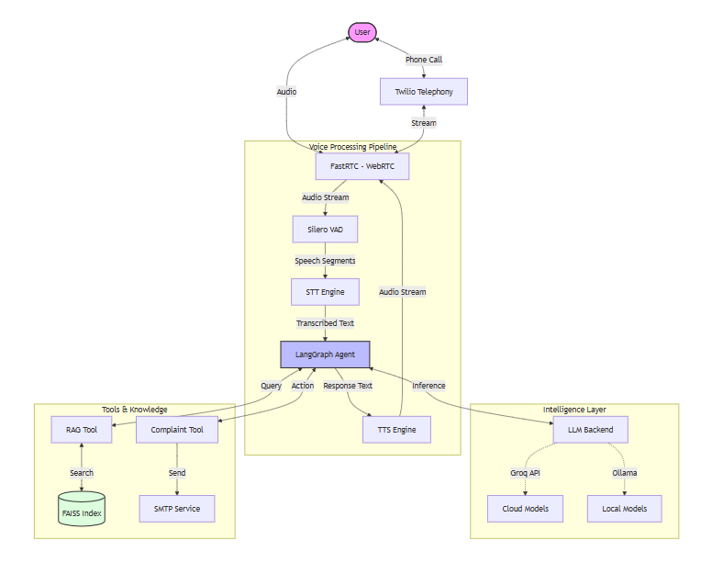

2. Key Features
Voice Interaction
- Real-time Speech-to-Text (STT):
  - Cloud: Integration with Groq's Whisper API (Whisper-large-v3-turbo) for ultra-fast transcription.
  - Local: Fallback/Alternative support for Faster-Whisper (int8 quantization) running locally on CPU.
- Text-to-Speech (TTS):
  - Local: Uses Kokoro TTS (voice: af_heart) for high-quality, low-latency speech synthesis.
  - Cloud: Support for Groq TTS (via process_groq_tts).
- Voice Activity Detection (VAD): Utilizes Silero VAD to accurately detect speech start/stop and handle interruptions via ReplyOnPause.
Intelligent Agent (LangGraph and LangChain)
- ReAct Architecture: Built using LangGraph to enable reasoning and tool usage.
- Multi-LLM Support: Flexible backend configuration supporting:
  - Groq: Llama 3.1-8b-instant.
  - OpenAI/OpenRouter: Grok (x-ai/grok-4.1-fast).
  - Ollama: Local Llama 3.2 or Qwen models.
- Context Awareness: Maintains conversation history using InMemorySaver.
Tools for the Agent
RAG (Retrieval-Augmented Generation)
- Knowledge Base: Ingests structured company data (from renata_data.json) and converts it into text chunks.
- Vector Search:
  - Embeddings: Uses sentence-transformers/all-MiniLM-L6-v2.
  - Index: FAISS (Facebook AI Similarity Search) for efficient similarity retrieval.
- Tool: rag_search allows the agent to look up facts about Renata's mission, founders, and services.

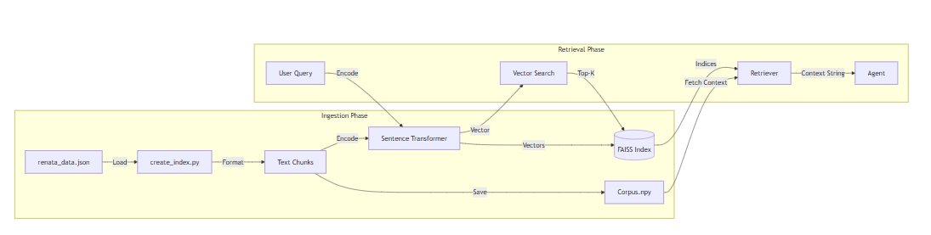
RAG Flow:

Complaint Management
- register_complaint tool captures user details (Name, Email, Issue).
- Generates a unique Ticket ID.
- Sends a formatted confirmation email via SMTP.
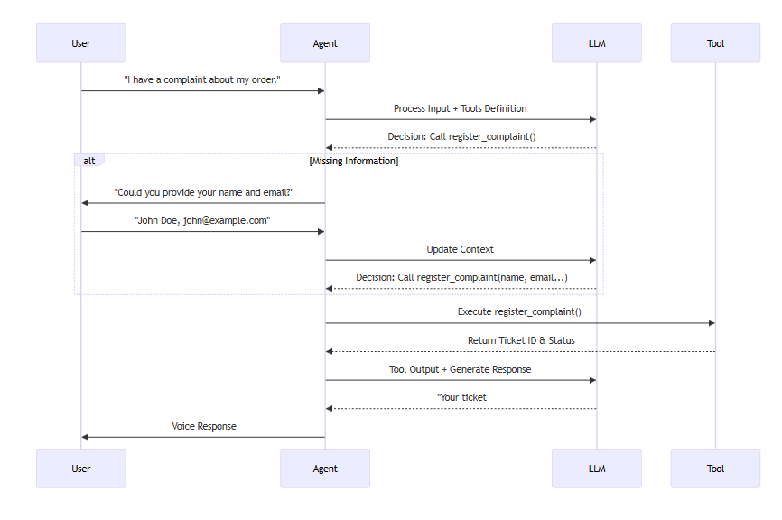
Tool Calling Flow

Interfaces
- Web UI: Custom Gradio interface for browser-based testing and demos.
- Telephony: Twilio integration (via FastRTC) to handle incoming phone calls.
- Tunneling: ngrok integration to expose the local server to the public internet for phone testing.

3. Technologies & Approaches
Component | Technology / Library | Approach
Language | Python 3.10+ | Core logic and scripting.
Streaming | fastrtc | Handles WebRTC audio streaming, VAD, and turn-taking logic.
Web Framework | FastAPI, Uvicorn | Serves the application and handles WebSocket connections.
Agent Framework | LangGraph, LangChain | Orchestrates the agent's reasoning loop and tool execution.
LLM Backend | Groq SDK, Ollama, OpenAI SDK | Provides the intelligence layer.
Vector DB | FAISS, numpy | Stores and retrieves semantic embeddings for RAG.
Embeddings | sentence-transformers | Converts text to vector representations.
STT | faster-whisper, Groq API | Converts audio to text (Hybrid approach).
TTS | Kokoro, Groq API | Converts text to audio (Hybrid approach).
Utilities | loguru, python-dotenv, smtplib | Logging, configuration, and email services.

4. Progress Structure
The project is currently in a Functional Prototype / MVP state.
- Core Agent Logic: The LangGraph agent is fully implemented with the LLM and its tools (RAG and Complaint tools) (src/company_support_agent.py).
- RAG Pipeline: The data ingestion and indexing script (src/rag_integration/create_index.py) is complete and functional.
- Voice Pipeline (Cloud): src/main.py
  - Integrates Groq's Whisper-large-v3 for Speech-to-Text.
  - Integrates Groq's PlayAI for Text-to-Speech.
  - Integrates Groq's Llama 3.1-8b-instant for the LLM.
  - All components are written, integrated, and tested for cloud-hybrid operation.
  - Also tested extensively with OpenRouter's xAI Grok, which also functions well.
- Voice Pipeline (Local): src/test_native_fastrtc.py successfully demonstrates a fully local pipeline.
  - Speech-to-Text (STT):
    - Initial tests with moonshine-base via fastRTC were unsatisfactory.
    - Shifted to Ctranslate2's faster-whisper model, which performs well.
  - Local Large Language Model (LLM): Ollama is used.
    - Qwen3-0.6b works well but lacks tool calling.
    - llama3.2 offers tool calling but lacks precision.
    - Gemma is yet to be tested.
    - Prompt structure will be refined for accurate tool parameter calling.
  - Text-to-Speech (TTS): Handled by KokoroTTS provided by FastRTC.
- Telephony Integration: The basic structure for Twilio/Phone support is now fully configured and tested.
- UI: Gradio UI is working for browser-based interaction - tests how the FastAPI integration works

5. Expected Timeline for Completion
Phase | Task | Status | Estimated Completion
Phase 1 | Core Development | In Progress | Dec 1, 2025
 | Agent Logic & Tools Implementation | ✅ Done
 | RAG System Setup (FAISS + Embeddings) | ✅ Done
 | Basic Voice Streaming (FastRTC) | ✅ Done
 | Optimizing the prompt structure for better tool calling | ✅ Done
 | Optimizing the RAG embedding’s structure, embeddings and data quantity | 🔄 In Progress
 | Fine-tuning methods and GGUF conversion | 🔄 In Progress
 | Compare Qwen, Llama, Gemma for tool calling and context understanding | 🔄 In Progress
Phase 2 | Local Optimization | Done | Nov 30, 2025
 | Optimize Faster-Whisper latency (using wav instead of mp3) (and compare against moonshine-base) | ✅ Done
 | Fine-tune VAD thresholds | ✅ Done
 | Test Ollama integration for full offline capability | ✅ Done
Phase 3 | Telephony Integration | In Progress | Dec 2, 2025
 | Finalize Twilio Webhook setup | ✅ Done
 | End-to-end phone call testing | ✅ Done
 | Twilio billing setup | ⏳ Pending
Phase 4 | Deployment & Polish | In Progress | Dec 15, 2025
 | UV environment for the application | ✅ Done
 | Set up persistent database (SQLite/Postgres) | 🔄 In Progress
 | Final Documentation & Handover | 🔄 In Progress

